2021
Missouri Police Chiefs Conference
Vendor Registration

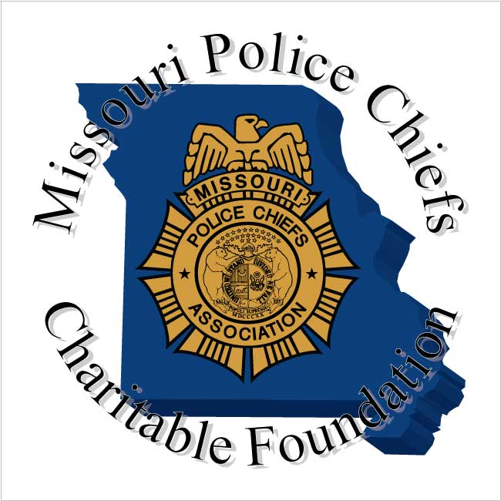

SAVE THE DATE!

May 2nd – 4th 2021

2021 Missouri Police Chiefs
Exhibitor Agenda

Sunday – May 2, 2021

9:00 am to 4:00 pm | Vendor Registration and Set - up
1:00 pm to 4:00 pm | Conference Attendee Training
5:00 pm to 6:00 pm  6:00 pm to 7:00 pm  7:00 pm to End | Opening Ceremony Dinner  Vendor Introductions and Short Presentation  Live Auction and 50/50 Drawing

Monday – May 3, 2021

7:00 am to 8:00 am | Breakfast and Vendor Mingle
9:00 am to 12:00 pm | Conference Attendee Training
12:00 pm to 1:00 pm | Lunch and Vendor Mingle
1:00 pm to 5:00 pm | Conference Attendee Training
6:30 pm | Hospitality Room Open

Tuesday – May 4, 2021

7:00 am to 8:00 am | Breakfast and Vendor Mingle
9:00 am to 12:00 pm | Conference Attendee Training
12:00 pm to 1:00 pm | Lunch, Vendor Prize Drawing
1:00 pm | Vendor Tear Down

Thank you for joining us!
Safe Travels

Important Information for the Vendors
Missouri Police Chiefs 2021 Conference
May 2 – 4, 2021

Vendor Booths
All vendor booths will be approximately 8 x 10 with one (1) 6 foot draped and skirted table, two (2) chairs, pipe & drape, wastebasket and company signage.

Shipping Instructions
If you have items/supplies that need to be delivered to the Hotel prior to you checking in, you should contact hotel directly at (1-800-826-8272) to make the appropriate arrangements. Please note* there are handling fees charged for all incoming and outgoing packages. For shipping of exhibit materials and display assembly, please utilize Page and Brown Convention Services. Exhibitor shipments sent to the Hotel will be re-routed to Page and Brown Convention Services and charged according to Page and Brown Convention Services prevailing rates.

When shipping boxes, letters or packages to Margaritaville Lake Resort using any shipping method other than the United States Post Office, please use the following format: Address your labels as follows, using the physical address:

Name: Recipient Name, Date of Arrival
Group: Missouri Police Chiefs Charitable Foundation
Attn: Convention Service Manager
Address: 494 Tan Tar A Drive
City/State: Osage Beach, MO 65065
# of Boxes/Pkgs: of

United States Postal use P.O. Box 188TT

Exhibitor Registration

Your exhibitor registration includes:

- The exhibit facility as programmed
- General maintenance of aisles, Hotel lighting, heating, air conditioning, and ventilation
- One 6' draped and skirted table, 2) chairs, pipe & drape, wastebasket, and signage
- Permanent carpeting throughout the exhibit hall
- Exhibit Services Coordinator

Vendor Information cont.

The above rental agreement does not include:

- Drayage and placement of display equipment
- Decoration and related services
- Security services
- Labor; for example, carpenters, electricians, and drapers
- Storage of any exhibit-related materials
- Lighting and electrical power. Current pricing is $55 for 2–110-volt outlets per booth. For years beyond 2020, your Convention Service Manager will provide updated pricing.
- Gas or water supply

Hold Harmless Clause

The exhibitor assumes the entire responsibility and liability for losses, damages, and claims arising out of exhibitor's activities on the Hotel premises and will indemnify, defend, and hold harmless the Hotel, its owner, and its management company, as well as their respective agents, servants, and employees from any and all such losses, damages, and claims.

Margaritaville Lake Resort will not be responsible or liable for any loss, damage or claims arising out of exhibitor's activities on the Hotel's premises except for any claims, loss, or damages arising directly from its negligence.

Storage

Due to the layout of the Hotel, storage space is not available for display materials and/or show merchandise. At the conclusion of the set-up operation, all related equipment, crates, trash, etc. must be removed from the premises no later than the last day of the exhibit show period.

494 Tan-Tar-A Drive, Osage Beach, MO 65065
1-(800) 826-8272

CONFERENCE ROOM RATES:
Inclusive room rate: $120.00 plus tax and lodging
(For Double, Queen & King Rooms)
1 Bedroom - $165.00 plus tax and lodging
2 Bedroom - $245.00 plus tax and lodging
.

HOTEL REGISTRATION:
By Phone: 1-(800) 826-8272 at the time you make your reservation inform the hotel you are with the MPCA “LE Combined Conference” and would like the special room rate.

Online: Reserve Online Now

Check-In: 4:00 pm
Check-Out: 11:00 am

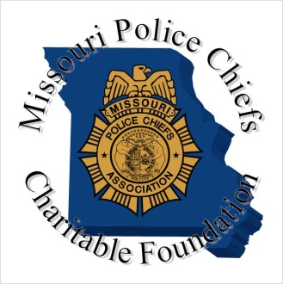
2021 Police Chiefs Conference
Vendor Registration Form

VENDOR:
BILLING ADDRESS: State Zip

BILLING EMAIL: PHONE: - -

The Registration Fee Includes 2 Vendor Representatives, additional Reps are $25 each.
REPRESENTATIVE NAME
REPRESENTATIVE NAME
ADDITIONAL REPS

REGISTRATION FEE: NO REFUNDS AFTER April 12, 2021
$700.00 Full Vendor Registration
$25.00 X Additional Reps TOTAL:
$100 .00 Late Registration Fee (After April 12, 2021)
Invoice above address
Payment is enclosed
(Vendor fee includes pipe, drape, chairs, table, signage, placement in conference book and waste basket)

Electricity is needed
We will be providing a prize for the vendor drawing

All Credit Card Payments will be charged a 3% fee for processing

Credit Card Number: 3 Digit Code

Expiration Date: Card type: Visa MasterCard Discover AmEx

Approval Signature:

Opening Ceremony Dinner, Auction and 50/50 Drawing Sunday May 2, at 5:00 pm. EVERYONE is encouraged to attend this fun event. Vendors will have an opportunity to speak to all attendees during this time.
Please indicate how many will be attending this event, including
PLEASE RETURN THIS FORM TO:
Missouri Police Chiefs Association
1001 East High Street
Jefferson City, MO 65101
Fax: (573) 636-6634 | Phone: (573) 636-5444

Vendor Sponsorship Agreement
Missouri Police Chiefs Charitable Foundation

Yes our company would like to be a sponsor at the 2021 Missouri Police Chiefs Conference.

Please check the level of sponsorship at which you would like to participate

Vendor Sponsorship Opportunities

Breakfast Sponsor $2000.00
Lunch Sponsor $3,000.00
Break Sponsor $750.00
Hospitality Sponsor $1,000.00
Banquet Sponsor $4,000.00
Major Conference Sponsor $8,000.00
(Major Sponsors will receive Advertisement in all conference documents, signage, and speaking opportunity)

Name:

Company/Business Name:

Address:

City: State: Zip:

Telephone:

Please make checks payable to: Missouri Police Chiefs Charitable Foundation

1001 East High Street

Jefferson City, MO 65101

All Sponsors please email your logo in a TIFF or JPEG format to: slindsey@mopca.com

THANK YOU FOR YOUR SUPPORT!

