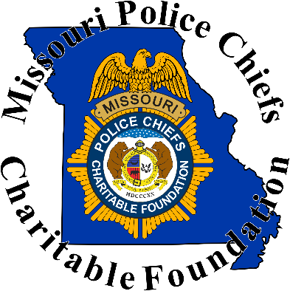

The class is limited to 36 seats, which will fill up quickly.

The cost for the week-long training is $350.00, which includes any required training materials, and lunch every day. Breakfast and Dinner will be on your own.
A special lodging rate of $ 96.00 a night (plus taxes and fees) has been arranged at the Courtyard by Marriott, Jefferson City MO. If your department or school is tax-exempt, make sure you bring a copy of your tax-exempt letter with you and present it at time of check in. You can follow this link to reserve your room with our special rate: Last Day to guarantee room is September 2, 2022.
Book your group rate for Missouri Police Chiefs
If you have any questions regarding this training, please contact MPCA Staff at 573-636-5444

Name:

Agency:

Address:

City: State: Zip:

Phone:___________________________ Email: ___

PAYMENT OPTION: Payment Enclosed INVOICE ME

